Zelda X. Cassalory About 176 words
1220 Inverted BLVD
Butte MT 59701
999-999-9999
you@supermail.com

Oghma Novel
  - A Template
by Tyler Tork
- Replace Boilerplate Text
There are two ways to use this file. You can just replace the contents with your text and then “save as” a different filename. Of, refer to Chapter Three for instructions on converting this document to a Word template for convenient use from the “New document” screen of Word.
Here are the places in this document you need to update.
The title page needs your title and subtitle (or delete the subtitle line), your byline, name, and contact information.
Double-click the page header on this page to edit it—insert an abbreviated title if your title is long, and just your last name. Double-click in the main text to switch back to it.
- Editing Your Manuscript
Your new document will already be formatted with “styles” that define the desired indentation, paragraph spacing, fonts and sizes according to the Oghma Style Guide. We recommend you don’t change these attributes, unless you need to have a limited amount of special typography, e.g. to reproduce the appearance of an old handbill. Bear in mind the editors may not have the same fonts installed as you have, however!
For a scene break, press Enter, type ***, and select the style “Section” on the new line.

***
Select View > Navigation Pane. This displays your manuscript in outline format, where each chapter is a main-level heading, and each section a second-level heading. By dragging things around in the navigation area, you can reorder scenes and chapters (though it may be hard to identify them unless you enter chapter and scene names). The chapters are automatically numbered.
To begin a new chapter, start a new paragraph and select the style “Chapter”. You can enter a chapter title if you wish, or just press Enter again to start typing the first paragraph.
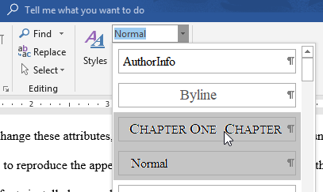
To signify the end of your manuscript, start a new paragraph, type – END – (or the like), and select the Section style.
- Installing this Template
How to install this as a known template in Word:
As you are reading this in Word, use menu File > Save As..., click the Browse button, and change the “Save as Type” field to “.dotx”. Word will automatically also change the destination folder to “Documents > Custom Office Templates”
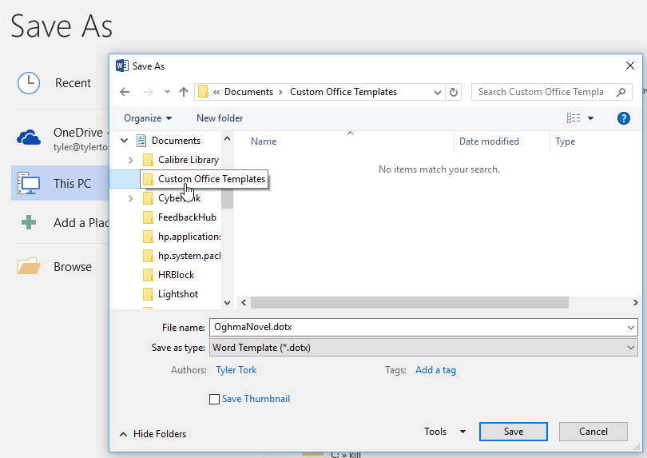
Henceforth, the template is available when you create new documents, on the “Personal” tab.
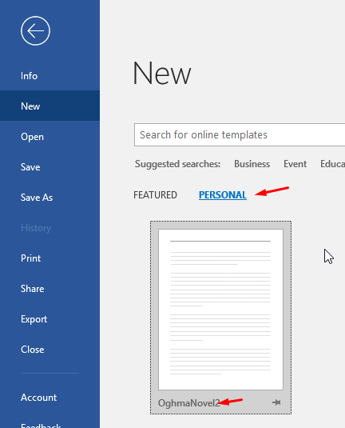

<<< END >>>

